Create and simulate a module that generates a signal that is logic LOW for 96 continuous cycles of an arbitrary clock, and Logic HIGH for 704 continuous cycles of the same clock.

This makes for a total of 800 cycles per period.

Pg 37 of the DE10-Lite manual has information about the timing of this signal.

Submit a screenshot of the module you created and it’s Modelsim simulation.

<Module created>

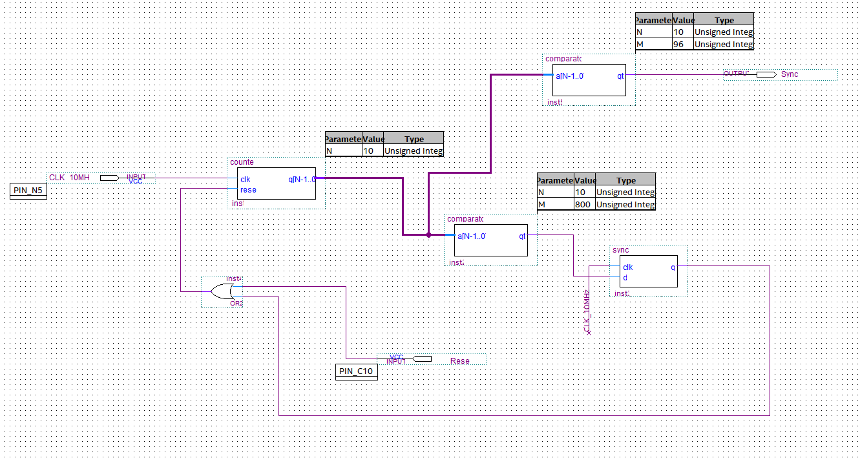

<Modelsim Simulation>

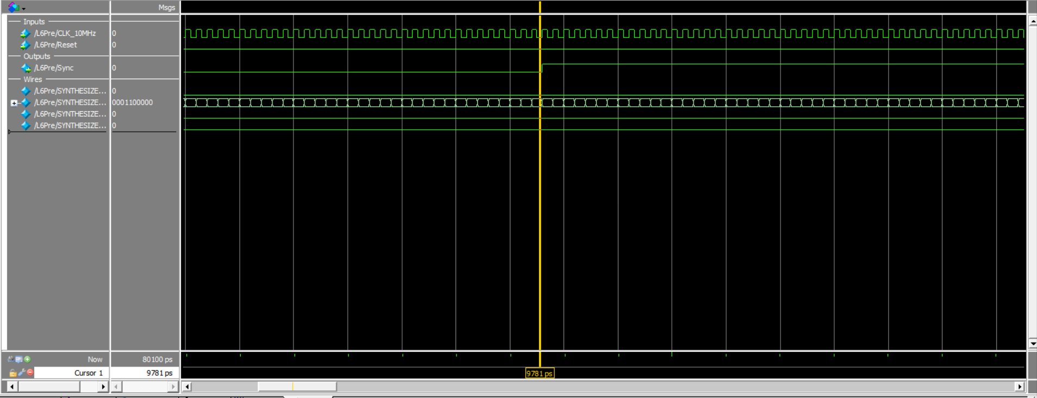

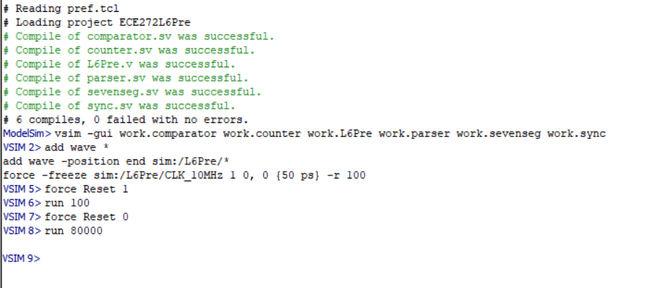

**(Note:** The clock period is 100ps.**)**